Prof. Anna Maria Salvi

University of Basilicata (UniBas), Sciences Department
Viale dell'Ateneo Lucano n. 10 Potenza 85100 Italy

Curriculum vitae

Education
•Degree in Chemistry (110/110 a.a.1982/’83) and Professional Habilitation (1984) awarded at the University of Rome 'La Sapienza' Italy
‘•Visiting Scientist’ at the University of Surrey, MSE/FEPS Department, Guildford (UK) for several periods from 1988 onwards. Enrolled in a part time PhD program for the academic five years 1990/91-1995/6 under the supervision of Prof. J.E. Castle.
PhD awarded in 1996 for the thesis entitled, "The relationship between atomic number and the intensity of the energy loss structure of the photoelectron spectrum" at the University of Surrey, England.

Employment
1984 –1986 University of Rome ‘La Sapienza’: Collaborative research with the Analytical Chemistry group (Prof. Luigi Campanella)
1986- 1998 University of Basilicata: Researcher (Permanent Position) in Analytical Chemistry
1998– Present time University of Basilicata: Associate Professor in Analytical Chemistry.

Academic activities
-• Member of the Italian chemical society (SCI) contributing to the activities of the Divisional Group of Analytical Spectroscopy and registered in the mailing list of the American chemical society (ACS)
In addition to the organizational activities, individual and collegial, required to university researchers and professors, particularly demanding in the start-up phase of the University of Basilicata, UniBas, the main institutional commitments to date concern:
-•1987-1989 researcher representative in the Administrative Council of UniBas (CdA) and for the biennium 1989/91 in the Faculty and Degree Course Councils
-•2000-2016 Coordinator assistant, vice coordinator from 2009-2010, of the Chemistry Doctorates for the cycles XVI-XXV and for the International Doctorate joined with the University of Valencia (Spain) –XXVI- XXVIII cycles.
-•2000-2016 Representative of cooperating stages, resulting from 2011 in the Erasmus agreement, between Chemistry/Science Department (University of Basilicata) and MSE/FEBS Department (University of Surrey, Guilford, UK): organization of internships abroad for undergraduates/graduates, PhD and post-doctoral students of UniBas and teaching mobility.
-•2004-2012 representative of Chemistry department (informative seminars, summer stages and other activities within the Lorenz project financed by MIUR for the consolidation of CAOS (University Centre for Students Orientation) for two consecutive ‘four years’ periods
• Appointed (2009) and reconfirmed (2011) as a member of the Chemistry Department in the scientific committee of CIGAS (Center for Interdepartmental Scientific Instrumentation)
• Appointed with prof. Carmine Serio (2011-2013) as Unibas representatives in the Technical Scientific Committee of the Val D'Agri Regional Observatory, established on 4 July 2011 at Marsico Nuovo (Pz).
-•2012-2020 President of CUG (Unified Guarantee Committee) UniBas for two consecutive ‘four years’ periods –the relevant activities are all reported on the website http://cug.unibas.it

Teaching activity
- Analytical Chemistry (LT Basic Courses)
- Analytical Chemistry of Surfaces and Interfaces (LM Basic Courses)

See detailed information from ESSE3 on http://docenti.unibas.it/site/home.html

Research activity at UniBas
The scientific activity centers on the study of surfaces and interfaces by XPS (X-ray Photoelectron Spectroscopy) and specializes in the analysis of spectra using a program for data elaboration that was developed in the course of the long-standing collaboration with the University of Surrey, UK (PhD thesis).
Work based on the analytical use of XPS in combination with other surface/bulk techniques has covered several projects of National and European significance aimed to the characterization of materials such as carbon fibres, meso and micro-porous catalysts, electrode surfaces for analytical sensors and biosensors, intermetallic compounds and electrochromic devices based on lithium ion intercalation. Recent works, in the field of biochemistry, have concerned the molecular and supra-molecular characterization of synthetic polypeptides and further advances of this research aim at the development of stratified biosensors for biomedical and pharmaceutical application.
Current academic and industrial research joined within the national Smart Cities (SCN_00520) project is devoted to diagnostic, preservation and restoration of artistic and monumental heritages.
In this context of important regional implications, the use of XPS combines with that of other analytical, spectroscopic and microscopic techniques, for research studies, shared with research groups and centres operating in Basilicata, aimed at preventing environmental risk and developing new methodologies for the protection of cultural heritages residing in the archaeological park ‘Matera Sassi’.
Within the Smart Cities project, the interdisciplinary contributions converge, for the selected case studies, to the understanding of:
- phenomena of degradation occurring outdoors/indoors in structural materials such as stone artefacts and monumental assets, due to surface interactions with reactive gases or acid rain or infiltration of stagnant water and other factors due to environmental specificities
- the effects of these interactions over time; 'pollution indicators’ for the monitoring and degradation prediction studies and planned interventions.
- microbial activities and local flora (biomonitoring) and characterization of synthetic gelled membranes, capable of absorbing pollutants and usable as convenient, inert and removable, supports for cleaning and bio-cleaning actions.

XPS/ESCA Laboratory
Prof Anna Maria Salvi has the scientific responsibility of the XPS/ESCA Laboratory daily operative for research and teaching activities with the technical assistance of Dott. Fausto Langerame.
See detailed information on her web site: http://docenti.unibas.it/site/home.html

It comprises:
A SPECS spectrometer Phoibos100-hemisperical (100 mm mean radius) -equipped with (5) -multi-channels detector-MCD5- that allows working with high lateral resolution while maintaining high sensitivity in the photo-electronic counting, with the following components and specificity:
• Analyzer with inlet and outlet slits and a lens system that allow four main operating modes:
• High and Medium Magnification (small areas: spot diameter up to about 100µm)
• Large and Medium area for angular studies (in- depth profile)
• Laser pointer and video camera for the sampling of the surface area and spot alignment. In addition, the instrument can be equipped with a special port for in situ transfer of samples, from the controlled atmosphere of an attached glove box, to avoid surface reactions before XPS analysis.
· Ultra High Vacuum (rotary, turbo and Ti-sublimation pumps) and water-cooling (chiller) systems.
Air-conditioned and soundproofing rooms. A ‘working area for samples preparation and surface’ treatments- provided of a built-in glove box with bench(s) and aspirator(s), optical microscope, supporting materials and tools for the preparative phases
Desk computer for XPS data acquisition and elaboration (implemented with dedicated program(s): CasaXPS from SPECS and NewGoogly^{4,5} for spectra’ curve-fitting, respectively).

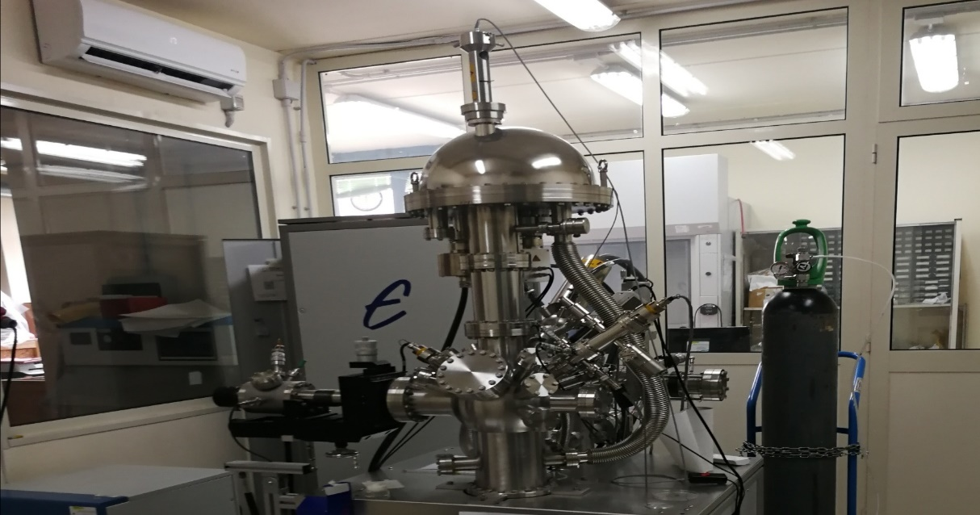
A view of the MCD-5 spectrometer Phoibos100 (SPECS) operative in the XPS laboratory (DiS)

The X-ray Photoelectron Spectroscopy (XPS) is based on the photoelectric effect introduced by Einstein in 1950¹ and was developed as an analytical technique ^{2,3} by K. Siegbahn (Uppsala University) who received the Nobel prize for his ideation in 1981.

XPS also known with the acronym ESCA (Electron Spectroscopy for Chemical Analysis), is a surface’ specific technique (depth of analysis of the order of nanometres), the most suitable to perform compositional analysis of the outer atomic/molecular layers of any sample, normally in a solid state.

The information provided by XPS is either qualitative (detection of elements and their chemical state) and semi-quantitative (relative intensity of detected chemical groups resolved by spectra curve-fitting)

The relevant publications and Congress contributions reporting on XPS studies and surface analyses of the investigated materials of scientific and technological importance are retrievable at the following websites:

- Iris/UniBas data- base from http://docenti.unibas.it/site/home.html

- https://scholar.google.com/citations?user=XNp9cn0AAAAJ&hl=it&oi=ao.

See detailed information of the all produced publications

XPS References
1. Einstein A. Über die von der molekularkinetischen Theorie der Wärme geforderte Bewegung von in ruhenden Flüssigkeiten suspendierten Teilchen (1905) Annalen der Physik 17 549-560.
2. Siegbahn K. Electron Spectroscopy for Atoms, Molecules and Condensed Matter – an Overview (1985) Journal of Electron Spectroscopy & Related Phenomena 36 (2) 113-129.
3. Physikalische Methoden in der Chemie Rudolph J. & Schroeder Eds.; VCH – Verlaggesellscharft (1985).
4. J.E. Castle, H Chapman-Kpodo, A Proctor, AM Salvi (2000) “Curve-fitting in XPS using extrinsic and intrinsic background structure” Journal of Electron Spectroscopy and Related Phenomena 106(1), 65-80
5. J.E. Castle & A.M. Salvi (2001) Journal of Electron Spectroscopy and Related Phenomena, 114–116, pp. 1103-1113.

